Investigation on BARS Condition Working Mechanism

On date of 24 Nov. 2016, Michael Loh (BA, PRR team) sent an email to Zhong Tang (ADS, eCommerce) and stated that:

“…, I did some testing and found that editing the text actually updates the original/master condition on the database. This is because BARS does not make a copy of the editable condition to associate with consent …”

In order to identify the issue and further strengthen our understanding about the BARS Condition Working Mechanism, we did the investigation by creating a couple of building consents and go through its life cycle in BARS application. We find that editing the text in the condition description field will NOT update the original/master condition on database, and BARS DOES make a copy of the editable condition to associate with the consent.

This paper is written by Zhong Tang (AD&S, eCommerce team) on 24 Nov. 2016.

1. **Investigation on Standard Condition (original/master)**

In BARS database, there is a table called “StandardCondition”, which holds the original/master conditions in database, as shown below:

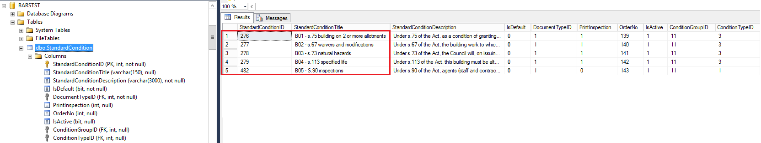

There are many Standard Conditions defined in BARS, we just list five of them here and use this five conditions with titles such as B01, B02 … B05 for our investigation.

Each Standard Condition can be categorized as three types:

* Default;
* Standard;
* Editable

A “Default” condition will be automatically added to the condition list once a new building consent is created; while a “Editable” condition will allow user to edit it once user select it in the condition screen for modification. Among them, let’s further look at the details of one of special Standard Conditions, i.e. **B01**.

Condition “**B01 - s.75 building on 2 or more allotments**”

This condition has the following description:

“*Under s.75 of the Act, as a condition of granting this consent, the specified allotments (insert lot and DP numbers) must not be transferred or leased except in conjunction with any specified other or others of those allotments*”

In above description, there is a holding space like this *(insert lot and DP numbers)*, in which user can fill it up with the text from the application details, for example, the building consent **20161413** has the “lot and DP numbers” in its application Details screen as shown below:

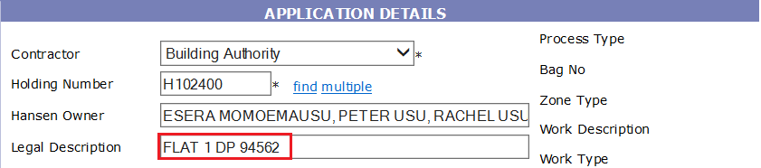

If a user selects this condition **B01,** then he/shecan grab the “***FLAT 1 DP 94562***” from the Legal Description field of the application details screen and fill the text in the **B01**’s condition description in condition details screen as shown below:

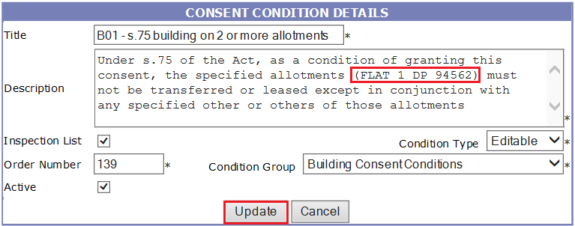

Then this modified condition with the consent “lot and DP number” in its holding space, will be associated with the consent and stored in database.

Please note that there’s also a holding space (*Insert Number*) in the standard condition **B04**. In my last document “**Discussion about the Building Consent Template**”, I have described the process of how this condition works.

1. **Practice of associating Standard Condition to a Building Consent**

The practice described here is to show the process of how to create a building consent, add a standard condition to the building consent and populate the holding space with the lot & DP number for the condition.

We create a new building consent 20161420 as show below:

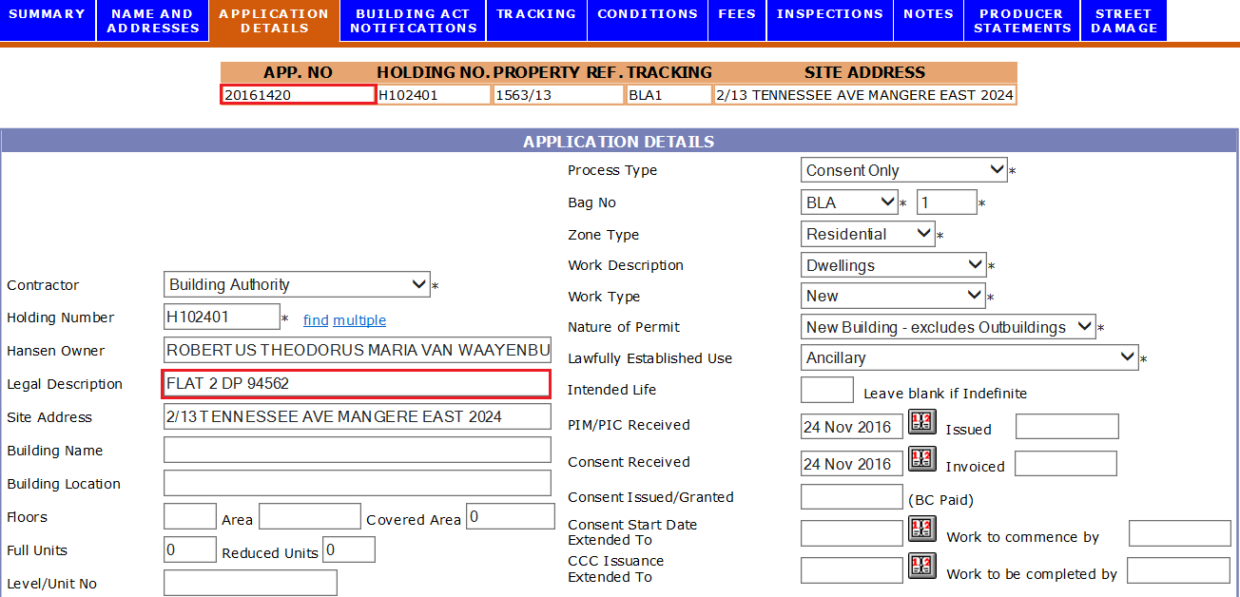

Go to its Condition screen, you will find the default condition **B05** is automatically added since it is default to every building consents:

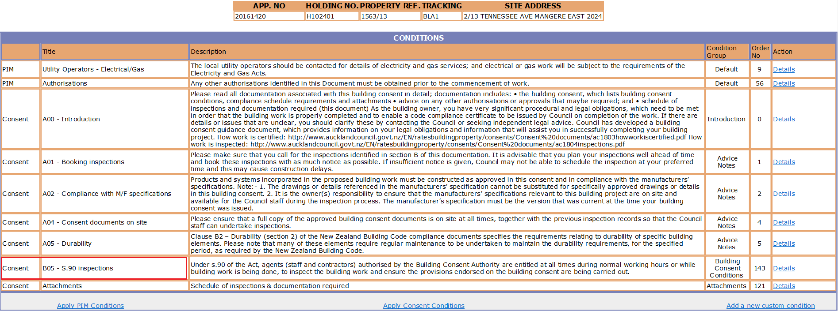

Now, click the  link to pop up “Apply Consent Contions” screen:

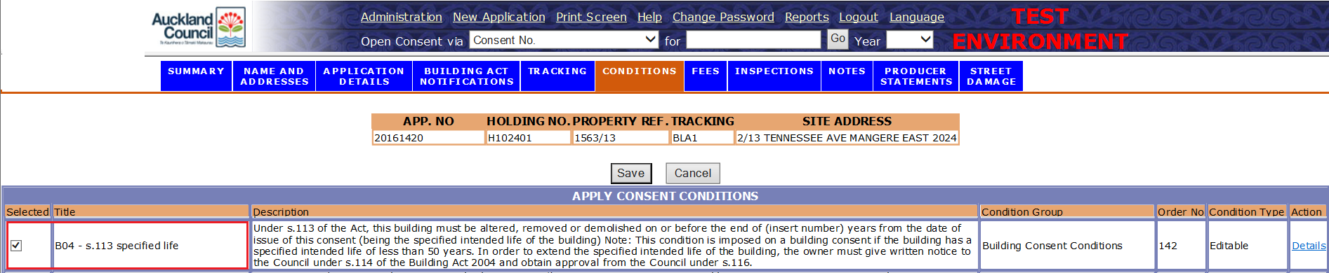

Select the standard condition **B01** and click the “Save” button, the condition B01 is now added to the list, please note that there’s a holding place in the description field which comes from the original/master condition, and a link  in the right-hand side:

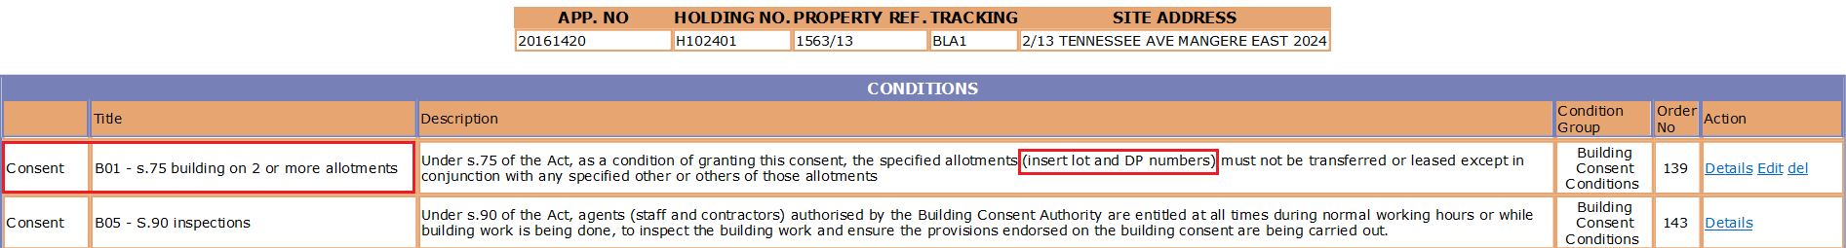

Next, user can go to application detail screen and copy the “lot & DP numbers” from its Legal Description field:

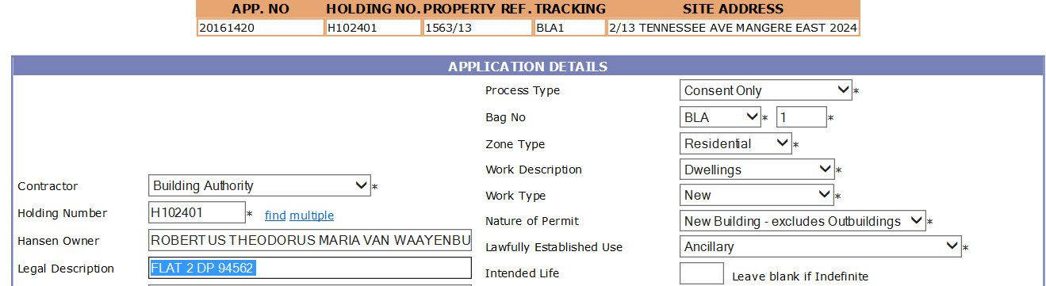

Then paste the “lot & DP numbers” into the holding space in the conditions screen:

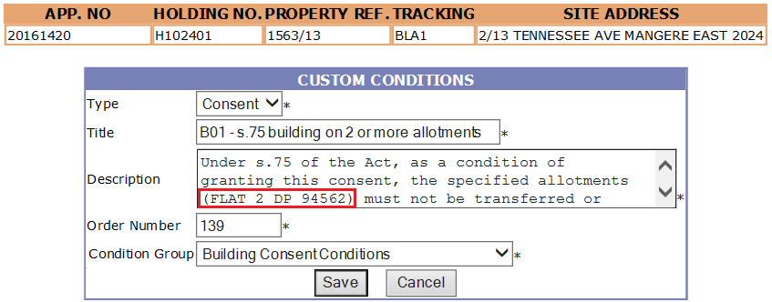

Click the button “Save”, this condition B01 now looks like the following with holding space populated with “lot & DP numbers” associating with this building consent:

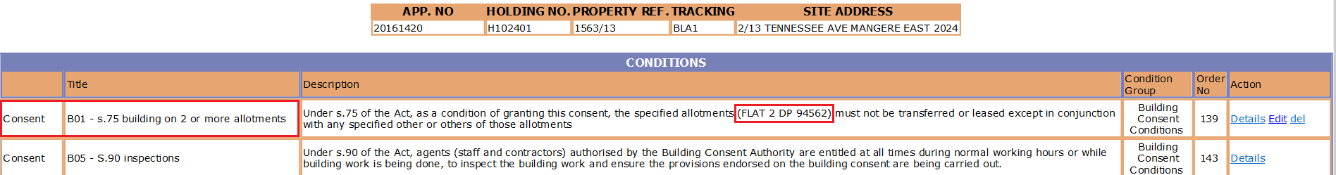

Please note that this modified condition B01 is stored in database table “ApplicationCondition” for this building consent (ApplicationID = 457431)

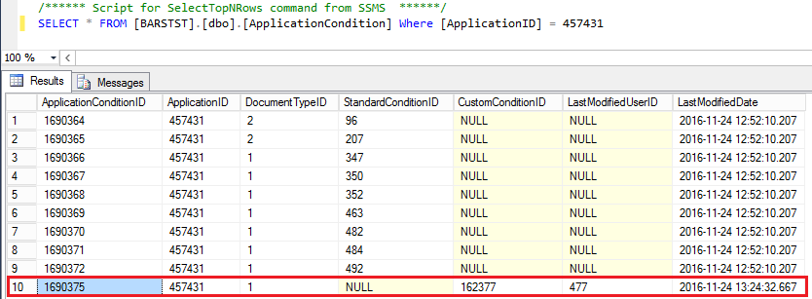

1. **Impact on the original / master condition**

Since Michael Loh stated that

“*I did some testing and found that editing the text actually updates the original/master condition on the database*”

In this section, we will show that there is No impact on the original/master condition, which means that the text actually wouldn’t update the original/master table in database.

* View from the application menu

Let’s go to “Administration” menu and select the item “CONDITIONS-CONSENT CONDITION LIST”

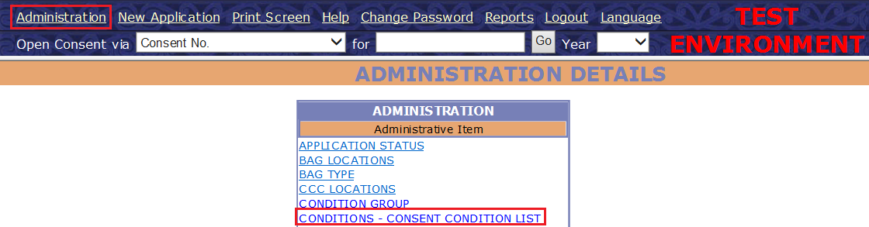

You can see all five standard conditions are NOT changed in their description field, the holding space still there:

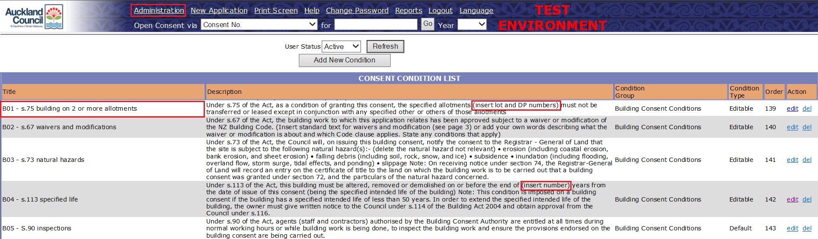

* View from the database table “StandardCondition”

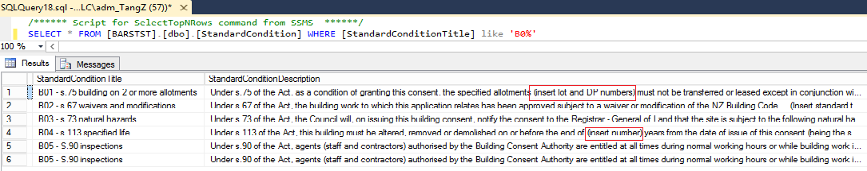

* View from the new consent

You may question that, how about create another new building consent to see if the holding space still not changed?

OK, let’s create a new building consent (20161421), add the standard condition B01 to it, and its condition screen looks like the following:

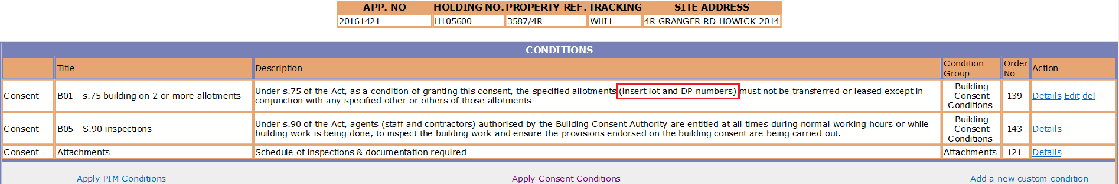

You will find the holding space is still there.

Therefore, we have enough evidence to ensure that an editable standard condition with holding space in it, after user populate data with the holding space, the changed standard condition will be associated with its building consent, while the original/master condition wouldn’t be affected.

1. **The meat of using the Holding Space in original /master condition**

In above sections, we describe the BARS condition working mechanism in details. Now we will be fascinated by the fact that producing report with the adaptive data (means that lot & DP numbers automatically reflects the changes according to the different setting in various building consents), is easy!

Before generating report, we must complete all building consent tracking paths, collect all relevant application fees and issue the building consent accordingly. All in all is to make the consent ready for reporting and the link  is visible in its Tracking screen:

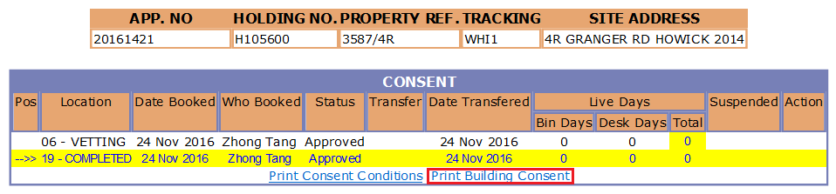

How click the link , this will pop up a new reporting window, we go to its second page, and it shows all condition as below:

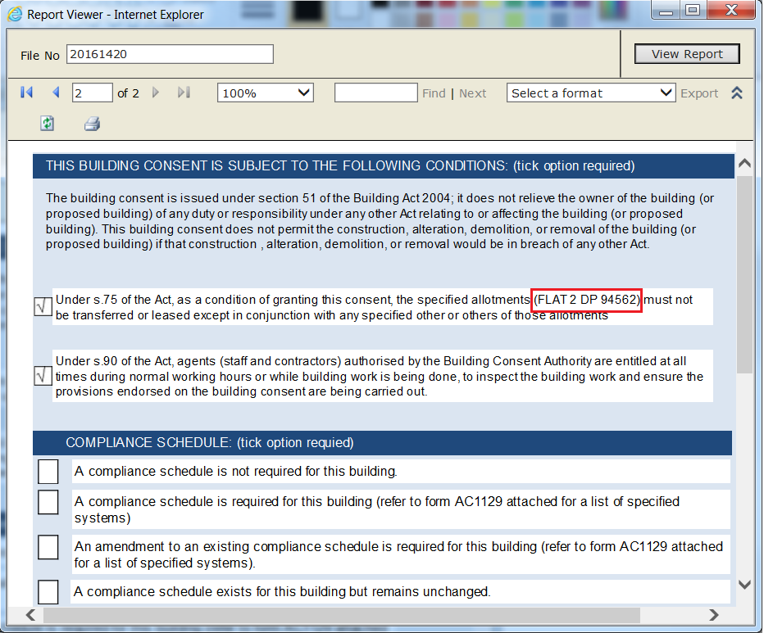

Clearly, the “lot & DP number” is EXACTLY shown in the condition **B01** as expected.

1. **Summary**

Our investigation clearly shows that original / master standard condition can be used as a template, each time when adding a standard condition to a particular building consent, the holding space can be populated with the data from application details. The original/master condition template wouldn’t be affected.